Finance Tracker Project Report
Personal Finance Tracker Excel Workbook
Prepared for portfolio documentation | Reporting period: July 2026 to June 2027

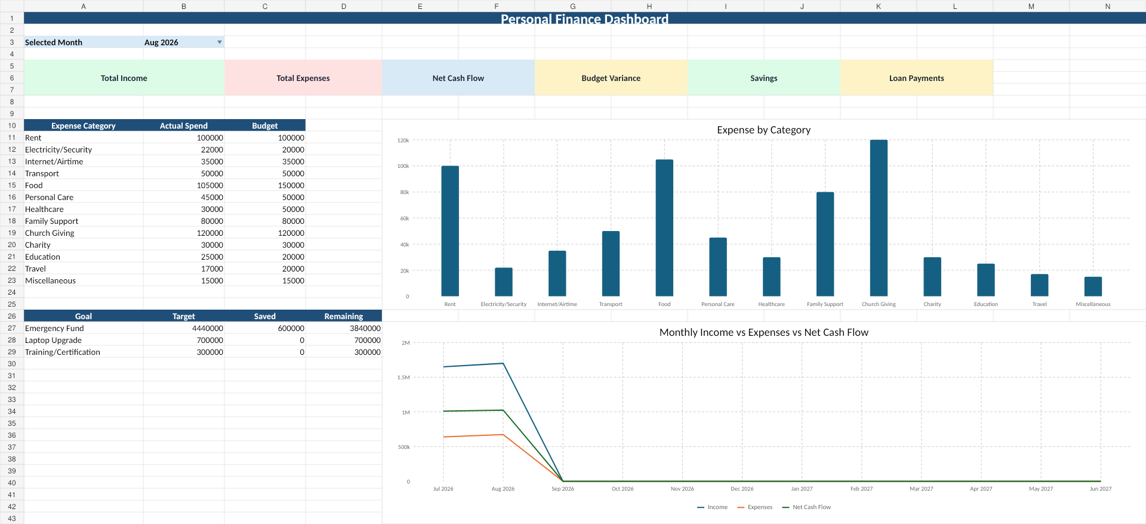

1. Executive Summary
The Personal Finance Tracker is an Excel-based workbook designed to monitor income, expenses, monthly budgets, savings, loans, and financial goals. It provides a clear view of cash flow, spending behaviour, savings progress, and budget performance. The dashboard also gives a quick monthly summary that helps the user make better financial decisions.
Based on the current workbook data, August 2026 shows total income of ₦1,700,000, total expenses of ₦674,000, net cash flow of ₦1,026,000, savings of ₦300,000, and loan payments of ₦50,000. The user is currently ₦66,000 under the August monthly budget of ₦740,000, which is a positive sign of expense control.

2. Project Overview
Item | Description
Project Title | Personal Finance Tracker Project
Project Type | Excel Dashboard / Personal Finance Management
Purpose | To monitor income, expenses, savings, loans, budgets, monthly summaries, and financial goals.
Main Users | Individual user, financial coach, portfolio reviewer, or personal finance learner.
Tool Used | Microsoft Excel
Output | Interactive workbook with dashboard, trackers, formulas, and summary sheets.

3. Workbook Structure
Sheet Name | Purpose
Dashboard | Displays the main KPI cards, selected month, category spending, budget comparison, goals summary, and visual overview.
Income | Tracks salary, commission, and other income sources by month, amount, expected date, and status.
Expenses | Tracks spending by date, month, category, subcategory, amount, payment method, and status.
Budget | Stores monthly and annual budget amounts by expense category and compares actual spend against budget.
Savings | Tracks savings contributions by date, month, savings type, amount, target account, and status.
Loans | Tracks loan information, payment month, payment amount, payment status, and outstanding balance.
Goals | Tracks target amount, current saved amount, remaining amount, target date, and status for each financial goal.
Monthly Summary | Combines monthly income, expenses, net cash flow, savings, loans, budget variance, and savings rate.
Categories | Stores lists used for dropdowns and standard categories.
README | Provides user guidance on how to update and use the workbook.

4. Key Financial Metrics
Month | Income | Expenses | Net Cash Flow | Savings | Loan Payments | Budget Variance | Savings Rate
Jul 2026 | ₦1,650,000 | ₦640,000 | ₦1,010,000 | ₦300,000 | ₦50,000 | ₦100,000 under budget | 18.18%
Aug 2026 | ₦1,700,000 | ₦674,000 | ₦1,026,000 | ₦300,000 | ₦50,000 | ₦66,000 under budget | 17.65%

5. Financial Performance Analysis

5.1 Income Analysis
The tracker currently records two main income sources: salary and commission. July 2026 income was ₦1,650,000, while August 2026 income increased to ₦1,700,000. This increase came from a higher commission amount in August. Salary is treated as a stable monthly income source, while commission is marked as not guaranteed.

5.2 Expense Analysis
August 2026 total expenses were ₦674,000. This is lower than the monthly budget of ₦740,000, giving a positive variance of ₦66,000. The highest spending categories for August were Church Giving, Food, Rent, Family Support, and Transport.
Top August Expense Category | Amount | Share of August Expenses
Church Giving | ₦120,000 | 17.80%
Food | ₦105,000 | 15.58%
Rent | ₦100,000 | 14.84%
Family Support | ₦80,000 | 11.87%
Transport | ₦50,000 | 7.42%

5.3 Budget Performance
Budget Item | Value
Total Monthly Budget | ₦740,000
July Actual Spend | ₦640,000
August Actual Spend | ₦674,000
YTD Actual Spend | ₦1,314,000
YTD Budgeted Spend | ₦1,480,000
YTD Variance | ₦166,000 under budget
The budget section shows good control for the first two months of the financial year. July was ₦100,000 under budget and August was ₦66,000 under budget. Year-to-date actual expenses are ₦1,314,000 against a budget of ₦1,480,000, leaving ₦166,000 unspent compared with plan.

5.4 Savings and Goals
Goal | Target | Saved | Remaining | Progress | Status
Emergency Fund | ₦4,440,000 | ₦600,000 | ₦3,840,000 | 13.51% | In Progress
Laptop Upgrade | ₦700,000 | ₦0 | ₦700,000 | 0.00% | Not Started
Training/Certification | ₦300,000 | ₦0 | ₦300,000 | 0.00% | Not Started
The emergency fund is the strongest active goal. The current emergency fund target is ₦4,440,000, which represents six months of the ₦740,000 monthly budget. The workbook shows ₦600,000 saved toward this goal, leaving ₦3,840,000 outstanding. The laptop upgrade and training/certification goals have been created but have not started yet.

6. Excel Calculations Used
Calculation | Logic Used
Total Income | SUMIFS on Income Amount by selected month and Received status
Total Expenses | SUMIFS on Expense Amount by selected month and Paid status
Net Cash Flow | Total Income minus Total Expenses
Budget Variance | Budgeted Expenses minus Actual Expenses
Savings Rate | Savings divided by Total Income
Goal Remaining | Target Amount minus Current Saved
Goal Progress | Current Saved divided by Target Amount
The workbook is formula-driven. The dashboard pulls results from the detailed tracker sheets, while the Monthly Summary sheet provides a month-by-month view of the main financial position. This makes the workbook easier to update because the user only needs to add new income, expense, savings, loan, and goal records.

7. Dashboard Review
The dashboard provides a simple executive view of the selected month. It includes KPI cards for Total Income, Total Expenses, Net Cash Flow, Budget Variance, Savings, and Loan Payments. It also includes expense category comparison and goal tracking, making it useful for quick monthly review.
Dashboard strengths:
- Clear monthly KPI cards for fast review.
- Expense category breakdown helps identify where money is going.
- Budget comparison shows whether spending is above or below plan.
- Financial goals section shows target, saved amount, and remaining balance.
- Separate tracker sheets make the workbook easy to maintain.

8. Key Insights
- The user has positive cash flow in both July and August 2026.
- August income increased by ₦50,000 compared with July due to higher commission.
- Expenses stayed below budget in both months, showing good spending control.
- Food, Church Giving, Rent, and Family Support are major recurring expenses and should be monitored monthly.
- The emergency fund is active, but still has ₦3,840,000 remaining to reach the target.
- Loan information currently appears to be sample data and should be replaced with actual loan details before using the tracker for final reporting.
- The Monthly Required field for the Emergency Fund appears to have a formatting issue and should be formatted as currency, not date.

9. Recommendations
- Continue updating the tracker weekly to avoid missing transactions.
- Replace sample loan records with real loan balances, interest rates, due dates, and payment plans.
- Format all financial goal calculations as currency so monthly required amounts display correctly.
- Set a monthly savings target for Laptop Upgrade and Training/Certification goals instead of leaving them inactive.
- Review Food, Personal Care, Education, and Electricity/Security monthly because these categories can easily exceed plan.
- Use the Monthly Summary sheet for end-of-month review and compare actual results against budget.
- Add a yearly dashboard page later to track trends across the full July 2026 to June 2027 financial year.

10. Portfolio Project Summary
This Excel project demonstrates the ability to design a practical finance tracker using structured data tables, formulas, dashboards, category tracking, budget monitoring, and goal measurement. It is suitable for a data and business analysis portfolio because it shows spreadsheet design, KPI development, financial reporting, dashboard creation, and insight generation.

11. Conclusion
The Personal Finance Tracker provides a strong foundation for monthly financial management. It helps the user understand income, spending, savings, loans, and goals in one workbook. The current data shows positive cash flow, controlled spending, and active progress toward the emergency fund. With regular updates and minor formatting corrections, the workbook can serve as a reliable personal finance management tool and a strong Excel portfolio project.

